Exercise 1:

Suppose we have created a table named **employee** as follows:

1. **CREATE** **TABLE** employee(
2. **name** **varchar**(45) NOT NULL,
3. occupation **varchar**(35) NOT NULL,
4. working_date **date**,
5. working_hours **varchar**(10)
6. );

Next, we will insert some records into the employee table and then execute the [SELECT statement](https://www.javatpoint.com/mysql-select) to see the table data as follows:

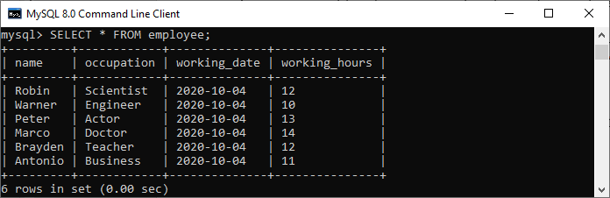

Next, we will use a **CREATE TRIGGER** statement to create a BEFORE INSERT trigger. This trigger is invoked automatically that inserts the **occupation = 'Leader'** if someone tries to insert the **occupation = 'Scientist'**.

1. mysql> DELIMITER //
2. mysql> **Create** **Trigger** before_insert_occupation
3. BEFORE **INSERT** **ON** employee **FOR** EACH ROW
4. **BEGIN**
5. IF NEW.occupation = 'Scientist' **THEN** **SET** NEW.occupation = 'Doctor';
6. **END** IF;
7. **END** //

If the trigger is created successfully, we will get the output as follows:

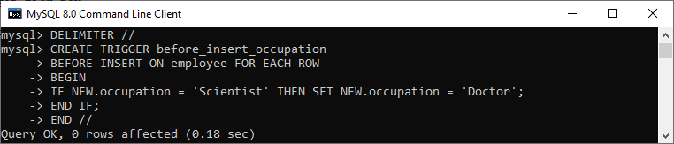

Exercise 2:

Here, we are going to create two tables "**customers"** and "**orders"** that contains the following data:

**Table: customers**

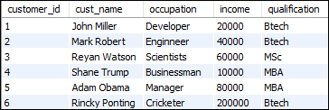

**Table: orders**

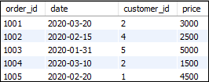

To select records from both tables, execute the following query:

1. **SELECT** customers.customer_id, cust_name, price, **date**
2. **FROM** customers
3. LEFT JOIN orders **ON** customers.customer_id = orders.customer_id;

After successful execution of the query, it will give the following output:

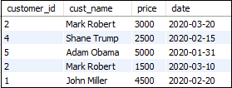

**Exercise 3:**

Let us first create two tables "students" and "technologies" that contains the following data:

**Table: student**

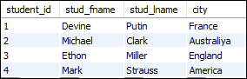

**Table: technologies**

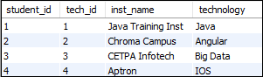

To select records from both tables, execute the following query:

1. **SELECT** students.stud_fname, students.stud_lname, students.city, technologies.technology
2. **FROM** students
3. **INNER** JOIN technologies
4. **ON** students.student_id = technologies.tech_id;

After successful execution of the query, it will give the following output:

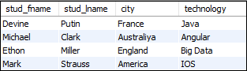

**Exercise 4:**

Here, we are going to create two tables **"customers"** and **"contacts"** that contains the following data:

**Table: customers**

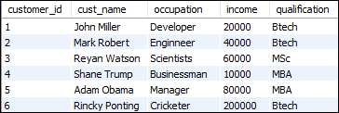

**Table: contacts**

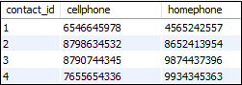

To fetch all records from both tables, execute the following query:

1. **SELECT** *
2. **FROM** customers
3. CROSS JOIN contacts;

After successful execution of the query, it will give the following output:

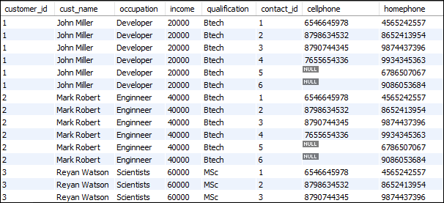

When the CROSS JOIN statement executed, you will observe that it displays 42 rows. It means seven rows from customers table multiplies by the six rows from the contacts table.